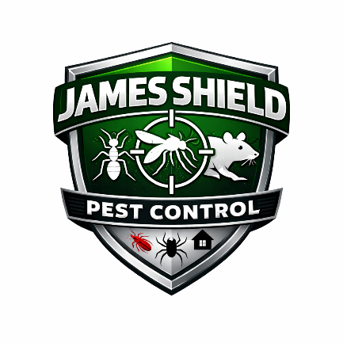
James Shield Pest Control
Paid Sick Leave Policy

1. Purpose
The purpose of this Paid Sick Leave Policy is to provide eligible employees with paid time off for qualifying health and safety-related reasons, while ensuring compliance with applicable state and local sick leave laws.

2. Scope
This policy applies to eligible full-time and part-time employees of James Shield Pest Control.

3. Eligibility
All full-time and part-time employees are eligible for Paid Sick Leave under this policy.
Employees must complete 90 days of employment before they are permitted to use accrued paid sick leave.

4. Sick Leave Benefit
Eligible employees are provided 24 hours of paid sick leave per calendar year.
- Sick leave is credited to the employee’s paid sick leave balance on January 1 of each year.
- Sick leave does not accrue monthly.
- Any unused sick leave remaining at the close of business on December 31 will be forfeited.
- Sick leave does not carry over into the following calendar year.

5. Permitted Uses of Paid Sick Leave
Eligible employees may use paid sick leave for the following covered purposes:
5.1 Personal or Family Health Needs
- The employee’s own mental illness, physical illness, injury, medical diagnosis, or preventive care.
- A family member’s mental illness, physical illness, injury, medical diagnosis, or preventive care.
5.2 Public Health Emergencies
- Closure of the employee’s workplace due to a public health emergency.
- Closure of the employee’s child’s school or place of care due to a public health emergency.
- When the employee or their family member has been instructed to isolate due to a communicable disease.
5.3 Domestic Violence, Sexual Violence, or Stalking
Sick leave may be used to obtain:
- Medical attention
- Counseling
- Legal services
- Relocation services
- Other services necessary to recover from domestic violence, sexual violence, or stalking
This leave may be used by the employee or for a covered family member.

6. Notice Requirements
6.1 Foreseeable Leave
When the need for leave is foreseeable, employees must provide reasonable advance notice.
6.2 Unforeseeable Leave
When the need for leave is not foreseeable, employees must provide notice as soon as practicable in accordance with company attendance procedures.
Sick leave requests may be made:
- Orally
- In writing
- Electronically
Where possible, the request should include the expected duration of the absence.

7. Documentation Requirements
If an employee uses paid sick leave for three (3) consecutive days or more, the Company may require reasonable documentation confirming the leave was used for a covered purpose.
Documentation will be handled confidentially in accordance with applicable laws.

8. Compensation and Benefits During Leave
During paid sick leave:
- Employees are compensated at their regular hourly rate of pay.
- Employees continue to receive the same benefits, including healthcare benefits, that they would normally receive during hours worked.
Sick leave pay does not include overtime premiums or special compensation unless required by law.

9. Relationship to Other Leave Policies
This Paid Sick Leave Policy operates independently of other leave policies.
Employees who may qualify for leave under other laws (such as Family and Medical Leave laws) or company policies should contact Human Resources for clarification regarding how those entitlements interact.

10. Non-Retaliation
James Shield Pest Control prohibits retaliation against any employee who requests or uses paid sick leave in accordance with this policy.

11. Administration
The Company reserves the right to interpret, modify, suspend, or terminate this policy at any time, subject to applicable federal, state, or local laws.

Approved By: ___________________________
Title: _________________________________
Effective Date: ________________________

